

**General Overview**

Federal Bank Limited is one of the major Indian commercial banks in the private sector headquartered at Aluva, Kerala. The Bank was incorporated on April 28, 1931 with the name Travancore Federal Bank Ltd.

The Bank operates in four segments: treasury operations, wholesale banking, retail banking and other banking operations. The Bank’s products and services include working capital, term finance, trade finance, specialized corporate finance products, structured finance, foreign exchange, syndication services and electronic banking requirements.

The bank has 1,272 branches, 1,948 ATMs and Cash recyclers as on 31 December 2020. The bank also has its representative offices in Abu Dhabi. The Bank offers to its customers, a variety of services such as Internet banking, Mobile banking, On-line bill payment, Online fee collection, depository services, Cash Management Services, merchant banking services, insurance, mutual fund products and many more as part of its strategy to position itself as a financial super market and to enhance customer convenience.

**Shareholding Pattern of the Company**

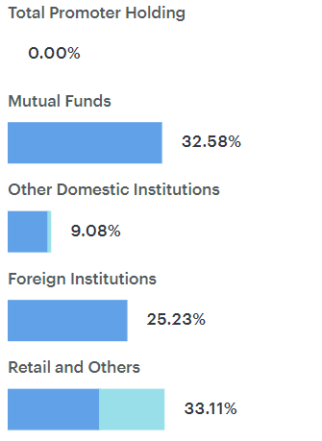The shareholding pattern of Federal Bank Limited as on December 2021 shows that 32.58% of the holdings are with Mutual Funds and 25.23% with Foreign Institutions. Of the 9.08% held by Other Domestic Institutions, 8.55% are held by Insurance firms. The remaining 33.11% is split by the Retail Investors (19.50%) and other parties (13.61%)

In last 3 months, mutual fund holding of the company has almost stayed constant

**Management of the company**

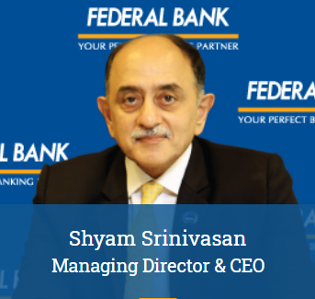

**Shyam Srinivasan** took charge as the Managing Director & CEO of Federal Bank on 23rd September 2010. He joined Federal Bank, equipped with the experience of leading multinational banks in India, Middle East and South East Asia, where he gained significant expertise in retail lending, wealth management and SME banking.

Shyam Srinivasan is an alumnus of the Indian Institute of Management, Kolkata and Regional Engineering College, Tiruchirappalli. He has completed a Leadership Development Program from the London Business School and has served on the Global Executive Forum (the top 100 executives) of Standard Chartered Bank from 2004 to 2010.

**Lakshmanan V** currently heads Treasury at Federal Bank. He joined Federal Bank on 12th April 2018 as Head – Sales (Derivatives & Treasury Products). Prior to joining Federal Bank, he worked with BNP PARIBAS, where he was Global Markets – Head, Corporate Treasury Sales, India. He earned his Engineering degree from Indian institute of Technology, Kanpur and Post Graduate Diploma in Management from SP Jain Institute of Management & Research, Mumbai.

**Venkatraman Venkateswaran**, is the group president & CFO currently working as Chief Financial Officer at Federal Bank. He is a Chartered Accountant with a graduate degrees in Law and Economics. He has more than three decades of professional expertise in Banking and Compliance, with international exposure. He is also equipped with an Executive MBA from Indian Institute of Management.

He has worked with HSBC and SCB in Global Finance Operations, Financial Compliance, Operations, Technology and support functions in various capacities. He joined Federal Bank in April 2021. Venkatraman has also held senior positions responsible for financial management, reporting and financial control in large corporations like Indian Rayon & Industries (Aditya Birla Group), the Singapore based Kewalram Chanrai Group and worked as CFO with Invensys India Pvt Ltd.

**SWOT Analysis of the Company**

**1. Strengths of Federal Bank**

Strengths refer to the capabilities or available resources that a company uses effectively for its development and overall growth. Federal Bank stands ahead of the competition because of the following strengths:

* Widespread Network: Federal bank has a strong and widespread network. It has over 1,200 branches spread all over India that effectively contributes to the bank’s overall effective and efficient customer services.
* Shareholders fund Utilization: Every bank has its Shareholders fund and it depends on the bank to use it in the best way possible. Federal Bank effectively uses shareholder funds that have helped it have a constant high ROE from the last two years.
* Increased Profit: Federal Bank is reporting ground-breaking records of profit. The bank’s net interest income increased by 9.4% to ₹1,418 crore as against ₹1,296 crore year-on-year.
* Managed Assets: Federal Bank has efficiently managed assets to Generate Profits.
* Increasing Customers: The Bank has a customer base of 10 million and it is expected to grow further in the future.
* Proper Initiatives: Federal Bank organises Innovative Marketing Campaigns and provides amazing offers to its customers.

**2. Weaknesses of Federal Bank**

Weaknesses in the SWOT analysis of a company are those factors that affect the growth of the company and thwart the company’s process from achieving its goals. There are a few weaknesses of federal bank, that it needs to address:

* Less Penetration: Federal Bank has lesser penetration in the urban market. This is a huge Weakness of the Federal Bank that could cost a price for the Bank.
* No Profits using capital: Every Bank has its own Capital. Capitals should be utilized to generate Profits. But the Federal Bank is inefficient in producing Profits using its Capital.
* High-Interest Payment: Federal Bank has higher Interest Payments compared to its Earning. This is a major weakness of the bank.
* Declining Revenue: Federal Bank has a declining Revenue every quarter.
* Removed as a Sponsor: Federal Bank was removed from the Principal Sponsor of IPL Team- Kochi Tuskers Kerala in 2011.
* High Volume/Top Loser: Federal Bank is listed on High Volume/Top Losers in Stock Market. And this is a bad part for the Federal Bank in the Stock Market.

**3. Opportunities for Federal Bank**

* Favourable factors that give a company a competitive advantage over other companies are known as opportunities in SWOT. Several opportunities for Federal Bank are:
* Small Enterprise: Federal Bank is a small enterprise Bank that is doing great as a financial institution. So, it has a very probable chance to grow in the near future.
* Rural Probability: If Federal bank offers its services in the rural sector it can be a game-changer for the bank as the rural sector can drive huge revenue and further opportunities for the bank.
* Urban Improvement: Federal Bank has the potential of improving its Urban Service. This can attract huge customers.
* Acquire Assets: Federal Bank can acquire assets of smaller units in smaller regions. This can help the Federal Bank to grow enormously.
* New Schemes: Federal Bank can come up with unique saving account schemes. These New Schemes help a branch to draw a large number of new customers.
* Digital Approach: Today’s World is marching towards Digitalization. Even in the field of Banking, there is huge scope in the Digital Payment System. So, they can launch their Digital Wallet for Digital Payments.

**4. Threats to Federal Bank**

Threats are the external factors that can cause harm to the company. These factors should be addressed as soon as possible to avoid any major damage to the organisation. The threats to the Federal Bank are:

* Economic Slowdown: The Economic Slowdown is a challenge for the overall Banking Sector in India. Thus, affecting the Federal Bank too.
* Competition: There are many banks in India that come up with innovative marketing campaigns and schemes regularly. The competition in the banking sector is almost cut-throat and the Federal bank needs to come up with innovative ideas in order to survive in the competitive market.
* Rural Reach: Microfinance having large shares in the rural region is a threat to private Banks.
* Technological Threats: Emerging Technology can also be a nightmare for Banks. Cryptocurrency can be a major threat to the Banking System.
* Strict Norms: The rules in the financial sector are getting strict day by day. Operating in such an environment is not a cakewalk and it affects the company’s growth too.

**Competitive Analysis**

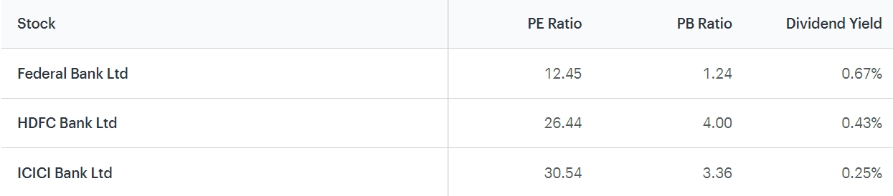

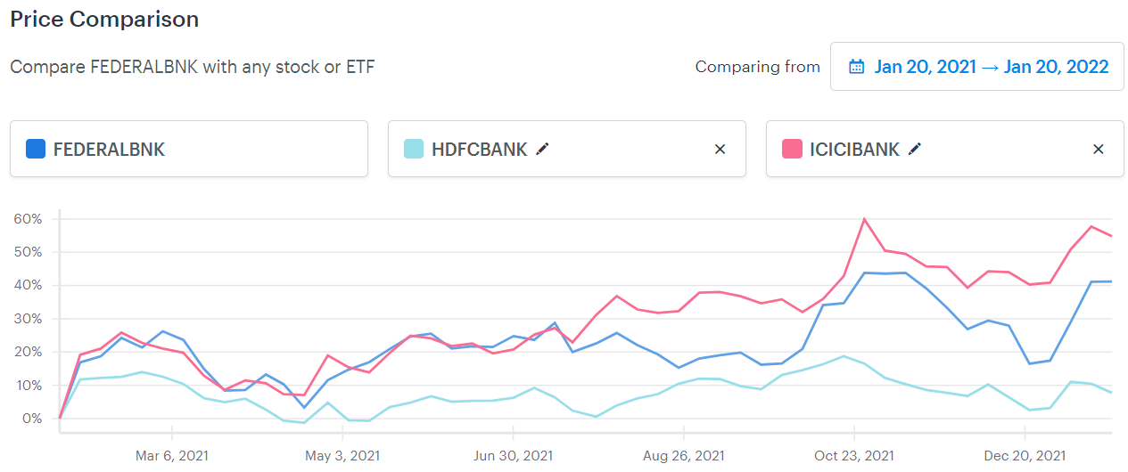

**Conclusion**

Federal Bank has always created a benchmark to its business & performance as compared to the other competitor banks in the industry. The bank is one of the leading brands in the banking and financial services sector of the country has always kept its customers on higher priority. It has come upon a long journey and is trusted by thousands of customers. Proper and Strategic SWOT Analysis of Federal Bank has upgraded it to achieve success.

Investment Checklist:

* Current price is less than the intrinsic value
* Stock has been generating better return on equity than bank FD
* Stock doesn't offer attractive dividend returns
* Good time to consider, as stock is not in overbought zone
* Stock not in ASM/GSM lists and not a lot of promoters holding is pledged

Federal Bank has always impressed its audience through its Unique Marketing Skills and Collaborative Campaigns. We can’t ignore the fact that people have started to shift towards private sector banks, and there’s always space for growth in this area. The Federal Bank should continue thriving in the competitive market by coming up with better policies and innovations.